**Logistic Regression with Python**

I will create a model for a telecommunication company, to predict when its customers will leave for a competitor, so that they can take some action to retain the customers.

### **Customer churn with Logistic Regression**

A telecommunications company is concerned about the number of customers leaving their land-line business for cable competitors. They need to understand who is leaving. Imagine that you’re an analyst at this company and you have to find out who is leaving and why.

### **About dataset**

We’ll use a telecommunications data for predicting customer churn. This is a historical customer data where each row represents one customer. The data is relatively easy to understand, and you may uncover insights you can use immediately. Typically it’s less expensive to keep customers than acquire new ones, so the focus of this analysis is to predict the customers who will stay with the company.

This data set provides info to help you predict behavior to retain customers. You can analyze all relevant customer data and develop focused customer retention programs.

The data set includes information about:

* Customers who left within the last month – the column is called Churn
* Services that each customer has signed up for – phone, multiple lines, internet, online security, online backup, device protection, tech support, and streaming TV and movies
* Customer account information – how long they’ve been a customer, contract, payment method, paperless billing, monthly charges, and total charges
* Demographic info about customers – gender, age range, and if they have partners and dependents

### **Load the Telco Churn data**

Telco Churn is a hypothetical data file that concerns a telecommunications company's efforts to reduce turnover in its customer base. Each case corresponds to a separate customer and it records various demographic and service usage information.

# Modeling (Logistic Regression with Scikit-learn)

Let’s build our model using **Logistic Regression** from Scikit-learn package. This function implements logistic regression and can use different numerical optimizers to find parameters, including ‘newton-cg’, ‘lbfgs’, ‘liblinear’, ‘sag’, ‘saga’ solvers. You can find extensive information about the pros and cons of these optimizers if you search it in internet.

The version of Logistic Regression in Scikit-learn, support regularization. Regularization is a technique used to solve the over fitting problem in machine learning models. **C** parameter indicates **inverse of regularization strength** which must be a positive float. Smaller values specify stronger regularization. Now let’s fit our model with train set:

from sklearn.linear_model import LogisticRegression

from sklearn.metrics import confusion_matrix

LR = LogisticRegression(C=0.01, solver='liblinear').fit(X_train,y_train)

LR

## Now we can predict using our test set:

yhat = LR.predict(X_test)

yhat

## **predict_proba** returns estimates for all classes, ordered by the label of classes. So, the first column is the probability of class 1, P(Y=1|X), and second column is probability of class 0, P(Y=0|X):

yhat_prob = LR.predict_proba(X_test)

yhat_prob

## **Evaluation**

### jaccard index

Let’s try jaccard index for accuracy evaluation. we can define jaccard as the size of the intersection divided by the size of the union of two label sets. If the entire set of predicted labels for a sample strictly match with the true set of labels, then the subset accuracy is 1.0; otherwise it is 0.0.

### **Confusion matrix**

Another way of looking at accuracy of classifier is to look at **confusion matrix**.

Confusion matrix, without normalization

[[ 6 9]

[ 1 24]]

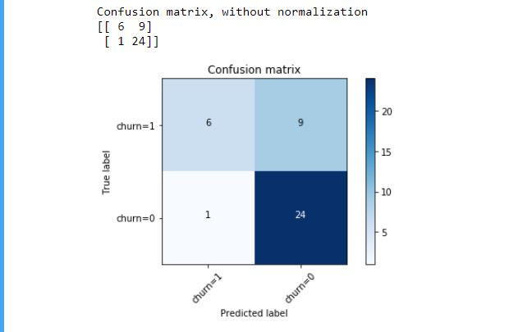

Look at first row. The first row is for customers whose actual churn value in test set is 1. As you can calculate, out of 40 customers, the churn value of 15 of them is 1. And out of these 15, the classifier correctly predicted 6 of them as 1, and 9 of them as 0.

It means, for 6 customers, the actual churn value were 1 in test set, and classifier also correctly predicted those as 1. However, while the actual label of 9 customers were 1, the classifier predicted those as 0, which is not very good. We can consider it as error of the model for first row.

What about the customers with churn value 0?

Let’s look at the second row. It looks like there were 25 customers whom their churn value were 0.

The classifier correctly predicted 24 of them as 0, and one of them wrongly as 1. So, it has done a good job in predicting the customers with churn value 0. A good thing about confusion matrix is that shows the model’s ability to correctly predict or separate the classes. In specific case of binary classifier, such as this example, we can interpret these numbers as the count of true positives, false positives, true negatives, and false negatives.

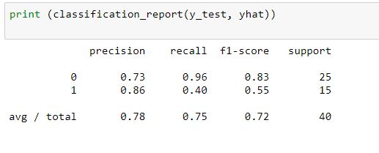

Based on the count of each section, we can calculate precision and recall of each label:

* **Precision** is a measure of the accuracy provided that a class label has been predicted. It is defined by: precision = TP / (TP + FP)
* **Recall** is true positive rate. It is defined as: Recall = TP / (TP + FN)

So, we can calculate precision and recall of each class.

**F1 score:** Now we are in the position to calculate the F1 scores for each label based on the precision and recall of that label.

The F1score is the harmonic average of the precision and recall, where an F1 score reaches its best value at 1 (perfect precision and recall) and worst at 0. It is a good way to show that a classifier has a good value for both recall and precision.

And finally, we can tell the average accuracy for this classifier is the average of the f1-score for both labels, which is 0.72 in our case.

### **log loss**

Now, let’s try **log loss** for evaluation. In logistic regression, the output can be the probability of customer churn is yes (or equals to 1). This probability is a value between 0 and 1. Log loss( Logarithmic loss) measures the performance of a classifier where the predicted output is a probability value between 0 and 1.